**Cairo University**

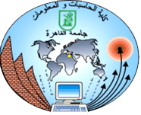

**Faculty of Computers and Artificial Intelligence**

Logo

San3a (Handcrafter freelancer)

By

**Maryam Abdelhamid Ibrahim 20210382**

**Alaa Hossam Mohamed 20210072**

**Asmaa Saleh Farghly 20211014**

**Ammar Mahmoud AbdElhafez 20210254**

**Mina Emad Abdrltawab 20211102**

**Abdelrahman Ashraf Abbas 20220215**

**Supervised by:**

**Dr. Noha Nagy**

**TA. Nourhan Ihab**

*Department of Information Systems, Faculty of Computers and Artificial Intelligence, Cairo University, Egypt 2025*

**Abstract**

This project presents a comprehensive handmade application designed to bridge the gap between artisans and customers, offering a unique platform for custom handmade products, AI-driven recommendations, and interactive features. The application addresses the growing demand for personalized, eco-friendly, and unique handmade goods by providing a suite of innovative tools and features. The primary purpose of this project is to create a user-friendly platform that enhances the shopping experience for customers while empowering artisans to showcase their craftsmanship and connect with potential buyers.

The significance of this project lies in its ability to revolutionize the handmade goods market by leveraging AI and user-centric design to create a seamless, interactive, and eco-conscious shopping experience. The results of this research are useful for both consumers seeking personalized, high-quality products and artisans looking to expand their reach and streamline their business operations. By addressing the challenges of modern e-commerce, this application fosters a vibrant community of creators and buyers, promoting sustainability, creativity, and innovation in the handmade industry.

**Table of Contents**

**Chapter 1** **Introduction 6**

1.1 Background and Motivation 6

1.2 Problem Statement 8

1.3 Objectives 8

1.4 Project Scope and Limitations 8

1.5 Project Methodology 10

1.6 Project Report Outline 10

**Chapter 2** **Market and Literature Survey 11**

2.1 Section 2.1 11

2.2 Section 2.2 4

2.2.1 Sub-section 2.2.1 4

**Chapter 3** **<Project title> Analysis 5**

3.1 Section 3.1 5

3.2 Section 3.2 5

**Chapter 4** **<Project title> Design and Implementation 6**

4.1 Section 4.1 6

4.2 Section 4.2 6

**Chapter 5** **<Project title> Testing and Evaluation 7**

5.1 Section 5.1 7

5.2 Section 5.2 7

**Chapter 6** **Conclusions and Future Work 8**

6.1 Section 6.1 8

6.2 Section 6.2 8

**List of Figures**

*Figure number Page Number*

Figure 1. Project Plan Example. 2

Figure 2. Example figure 4

Figure 3. Use Case Example 5

**List of Tables**

*Table number Page Number*

Table 1. Example Table 4

**List of Abbreviations**

|  |  |
| --- | --- |
| Abbreviation | Meaning |
| PPM | Project Process management |
|  |  |
|  |  |
|  |  |
|  |  |
|  |  |
|  |  |
|  |  |
|  |  |
|  |  |
|  |  |
|  |  |
|  |  |
|  |  |
|  |  |
|  |  |
|  |  |
|  |  |
|  |  |
|  |  |
|  |  |
|  |  |
|  |  |
|  |  |
|  |  |
|  |  |
|  |  |

# 

Chapter 1: Introduction

**1.1 Background and Motivation**

In recent years, there has been a significant shift in consumer preferences toward personalized, unique, and eco-friendly products. Handmade goods, in particular, have gained immense popularity due to their authenticity, craftsmanship, and sustainability. However, artisans and small-scale creators often face challenges in reaching a broader audience, managing custom orders, and competing with mass-produced items. On the other hand, customers seeking handmade products struggle to find reliable platforms that offer a wide variety of options, personalized recommendations, and seamless communication with artisans.

The rise of e-commerce and advancements in artificial intelligence (AI) have created opportunities to bridge this gap. While platforms like Etsy and Amazon Handmade have made strides in connecting artisans with buyers, there is still a need for a more comprehensive, user-friendly, and feature-rich application tailored specifically to the handmade industry. This project aims to address these challenges by developing a dedicated platform that not only facilitates the buying and selling of handmade products but also enhances the overall experience for both artisans and customers.

**Motivation**:

1. **Empowering Artisans**: Many talented artisans lack the resources or technical expertise to market their products effectively. This application provides them with a platform to showcase their work, connect with customers, and manage custom orders efficiently. Features like Notifications for Sellers and Add Offers on the Post enable artisans to respond quickly to customer requests, increasing their chances of securing business.
2. **Personalized Shopping Experience**: Customers today seek unique, customized products that reflect their individuality. The AI-Driven Gifting Feature, Style Advice AI, and AI To Design tools cater to this demand by offering personalized recommendations and design ideas. The Search by Photo feature further simplifies the process of finding products that match the user's preferences.
3. **Sustainability and Eco-consciousness**: With growing awareness of environmental issues, consumers are increasingly drawn to eco-friendly products. The Eco-friendly Flag highlights sustainable items, helping users make informed choices that align with their values.
4. **Convenience and Efficiency**: The application streamlines the shopping process with features like Express Delivery Flag, Comparison Tool, and Recommendation System, saving users time and effort. The Event Reminder System and Wishlist add convenience, while the Points system incentivizes repeat purchases.
5. **Community Building**: The platform fosters a sense of community by enabling direct communication between artisans and customers through the Chat feature. The Online Trade Show and Bazar On Application create opportunities for artisans to showcase their work and engage with a wider audience.
6. **Supporting Local Economies**: By promoting handmade products and hosting Ads for Offline Bazar, the application supports local artisans and small businesses, contributing to the growth of local economies.
7. **Innovation in E-commerce**: This project leverages cutting-edge AI technologies to create a unique and interactive shopping experience. Features like AI-Driven Gifting, Style Advice AI, and AI To Design demonstrate the potential of AI to transform the handmade goods market.
   1. **Problem Statement**

* In today's market, artisans often struggle with limited exposure and the exploitation of their work by shop owners, who take a significant portion of their profits. Additionally, customers seeking custom handcrafted products often face challenges in finding artisans who can accurately translate their ideas into tangible items.
* The current marketplace lacks an efficient, user-friendly platform that connects artisans directly with customers and empowers both parties. Artisans need a solution to showcase their talents, receive fair compensation, and gain exposure, while customers need a seamless way to communicate their product desires and receive personalized handcrafted items.
  1. **Objectives**
* Our e-commerce helps to connect artisans and Clients by providing a platform for artisans to showcase and sell handcrafted products directly to clients.
* we help customers make product requests by allowing clients to find or create products by uploading images or describing their vision for artisans to fulfill.
* we try to help the customer with personalized gifts by offering tailored gift recommendations based on client-provided information about the recipient.
* we are looking forward to increasing Artisan Income, enabling artisans, including stay-at-home individuals, to generate additional income through their crafts.
* we care about boosting artisan visibility by promoting artisans with tools like media content, reviews, and workshop ads to build trust and attract clients.
* because we are looking for customer and artisan comfort, we provide flexible payments and offers, we provide artisans the tools to create special offers and ensure clients have flexible payment options.
  1. **Project Scope and Limitations**
* **Scope**:
* Development of a mobile application with 27 features, including AI-driven tools, ethical shopping flags, and interactive social features.
* Target audience: Artisans and customers in the handmade goods market.
* Focus on personalization, customization, and ethical shopping.
* **Limitations**:
* Technical complexity of AI features like photo search and gifting recommendations.
* Resource constraints, including budget and development expertise.
* Competition from established e-commerce platforms.
* Dependence on third-party logistics for delivery.

**By the end of this section, you should include the initial project plan, team members, and their main responsibilities in the project.**

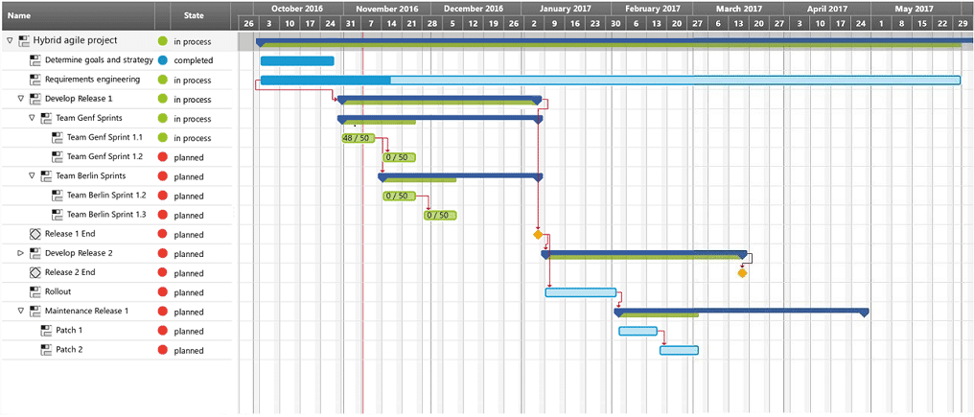

**Figure 1. Project Plan Example.**

|  |  |
| --- | --- |
| **Name** | **Responsibility** |
| Maryam | Frontend (Flutter) |
| Alaa | Frontend (Flutter) |
| Asmaa | UI/Ux |
| Ammar | Backend (next) |
| Mina | Backend (next) |
| AbdElrahman | AI Developer |

* 1. **Project Methodology**
* **Mixed Approach (Waterfall and Agile)** We used a mixed approach combining Waterfall and Agile methodologies as our project life cycle. This hybrid approach leverages the structured planning of Waterfall and the flexibility of Agile to ensure a balanced and efficient development process.
* **Initial Planning and Requirements Gathering (Waterfall):** The project will begin with a detailed requirements analysis, including functional requirements, user personas, and use cases. This phase will also include a SWOT analysis, gap analysis, and feasibility study to ensure the project is well-defined and achievable. A comprehensive project plan will be created, outlining the timeline, milestones, and deliverables.
* **Iterative Development (Agile):** Once the initial planning is complete, the development process will shift to Agile. The project will be broken into smaller sprints, each focusing on delivering specific features (e.g., AI-driven gifting, photo search, eco-friendly flags). At the end of each sprint, the team will review progress, gather feedback, and make necessary adjustments. This iterative process ensures that the product evolves based on real user needs and feedback.
* **Testing and Deployment (Agile):** deployment and testing will follow an Agile approach, utilizing Continuous Integration and Continuous Deployment (CI/CD) practices. This allows for rapid iterations and quick feedback, ensuring that the product is consistently updated and improved post-launch.
  1. **Project Report Outline**

This section demonstrates the documentation outline as follows:

- Chapter 2 presents the literature review of ……

- Chapter 3 presents the analysis of ………..

- Chapter 4 presents ……….. ………..

- Chapter 5 presents ……….. ………..

- Chapter 6 concludes the work and lessons learned, then sheds the light to future work.

Chapter 2: Market and Literature Survey

**2.1 Competitors Table**

|  |  |  |  |  |  |
| --- | --- | --- | --- | --- | --- |
| **Feature** | **San3a** | **Amazon** | **Creativeegypt** | **Marketchino** | **Alibaba** |
| **Search by Photo** | ✔ | ✕ | ✕ | ✕ | ✔ |
| **AI-driven Gifts** | ✔ | ✕ | ✕ | ✕ | ✕ |
| **Event Reminder** | ✔ | ✕ | ✕ | ✕ | ✕ |
| **Create Wishlist** | ✔ | ✔ | ✕ | ✔ | ✔ |
| **Share Wishlist** | ✔ | ✔ | ✕ | ✕ | ✔ |
| **Chat** | ✔ | ✕ | ✕ | ✕ | ✔ |
| **Gift Cards** | ✔ | ✔ | ✕ | ✕ | ✔ |
| **Comparison Tool** | ✔ | ✕ | ✕ | ✕ | ✕ |
| **Recommend Another Cheapest Product** | ✔ | ✕ | ✕ | ✕ | ✕ |
| **Rating System** | ✔ | ✔ | ✕ | ✔ | ✔ |
| **Trend Section** | ✔ | ✕ | ✕ | ✕ | ✕ |
| **Eco-Friendly Flag** | ✔ | ✕ | ✕ | ✕ | ✕ |
| **AI to Design** | ✔ | ✕ | ✕ | ✕ | ✕ |
| **Express Delivery Flag** | ✔ | ✔ | ✕ | ✕ | ✕ |
| **Special Order (Faster Delivery)** | ✔ | ✔ | ✕ | ✕ | ✕ |
| **Points** | ✔ | ✔ | ✕ | ✔ | ✔ |
| **History of Watched Products** | ✔ | ✔ | ✕ | ✕ | ✔ |
| **Seller Customizable Profile** | ✔ | ✕ | ✕ | ✕ | ✕ |
| **Online Bazar Section** | ✔ | ✕ | ✕ | ✕ | ✕ |
| **Ads for Offline Bazar** | ✔ | ✕ | ✕ | ✕ | ✕ |
| **Recommendation System** | ✔ | ✔ | ✕ | ✕ | ✔ |
| **Add Order Post** | ✔ | ✕ | ✕ | ✕ | ✕ |
| **Add Offers on Posts** | ✔ | ✕ | ✕ | ✕ | ✕ |
| **Add One-Piece Offers** | ✔ | ✕ | ✕ | ✕ | ✕ |
| **Get Interests from User** | ✔ | ✔ | ✕ | ✕ | ✔ |
| **Seller Notifications** | ✔ | ✔ | ✕ | ✕ | ✔ |
| **Discount Offers** | ✔ | ✔ | ✕ | ✕ | ✔ |
| **Payment Gateways** | ✔ | ✔ | ✕ | ✔ | ✔ |
| **Reels for Sellers** | ✔ | ✕ | ✕ | ✕ | ✕ |

*Table 1: competitors' table*

* 1. **Surveys**
     1. **Online Surveys**
  + **Aytm.com:**
* They asked 1,000 respondents on August 9-11-2016 about their thoughts on the market for handmade products. There’s a rising demand for handmade items in the gift industry as a whole.

Of those who have purchased handmade items, 53% have done so at craft fairs. 39% have bought handmade items at flea markets. 30% have bought them from local stores. 27% have bought them from farmer’s markets. 25% have purchased handmade products on eBay and another 25% on Etsy. 20% have purchased handmade items on Amazon. 10% have bought from independent online stores. 6% have bought from other marketplace sites. And 5% have purchased handmade 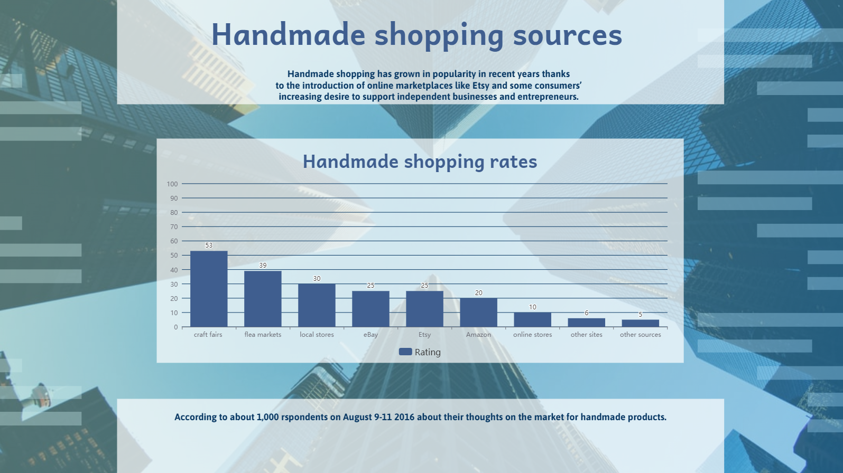items from other sources, like from friends directly or through Facebook.

*Figure 1: survey about handmade shopping sources*

In addition, 51% of handmade shoppers said that they have purchased handmade fashion accessories. 46% have purchased home items. 42% have bought holiday items or decorations. 39% have bought artwork or prints. 34% have bought food items. 30% have bought handmade clothing. 17% have bought toys or kids' items from handmade sellers. And 5% have purchased other types of products, such as cards or paper goods

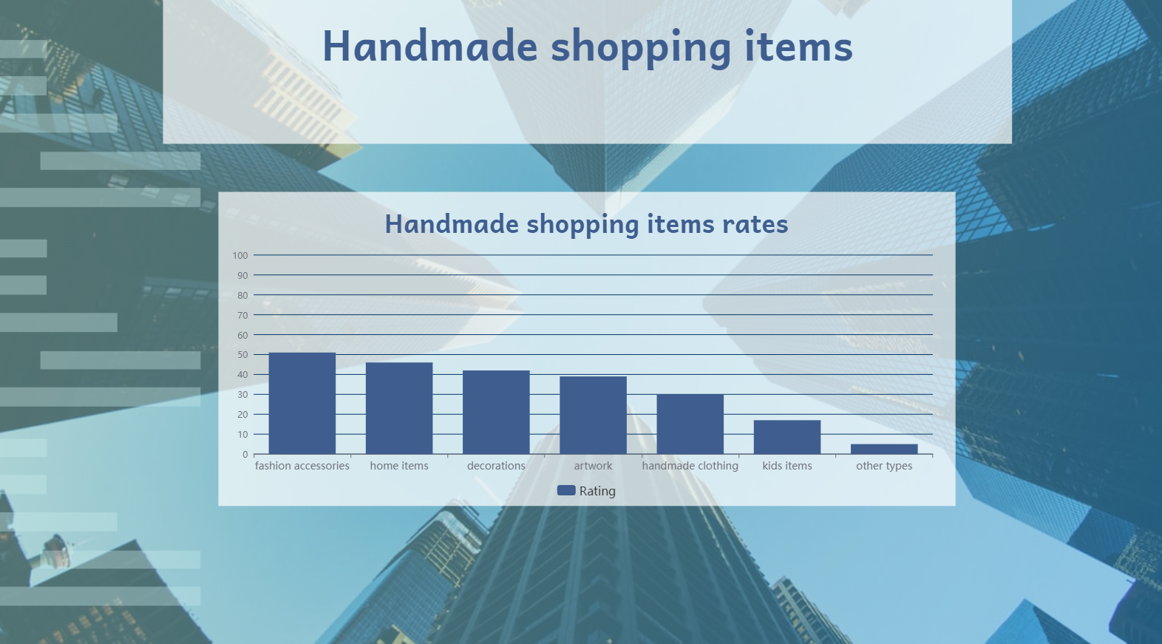

*Figure 2: Handmade shopping items*

In general, 48% of respondents said handmade shopping has become more popular in the past five years. 49% think that handmade shopping is likely to continue gaining popularity over the next five years. And **47% said they are at least somewhat likely to purchase handmade items over the next year.**

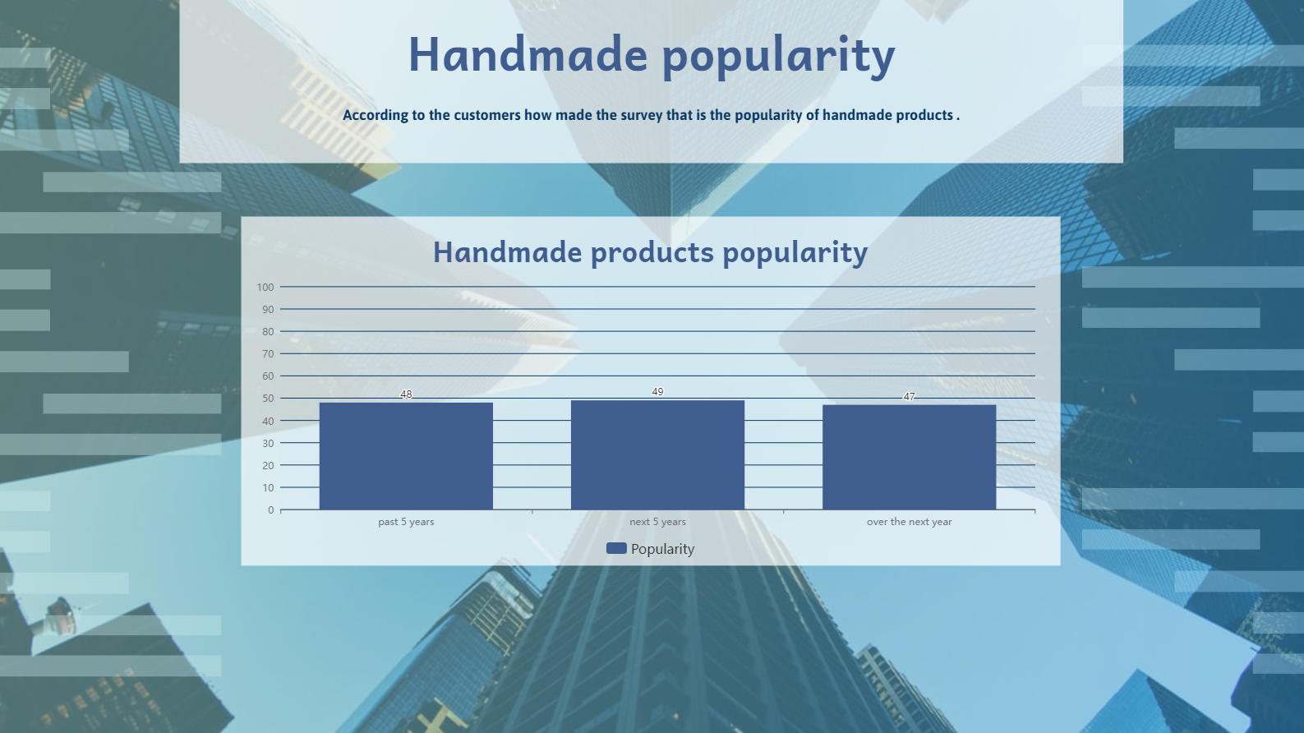

*Figure 3: Handmade popularity*

Of those who have purchased handmade items, **81% said they chose to buy handmade because they could get truly unique items.**51% said they like buying handmade items to support small businesses. And 30% cited cost savings when buying handmade items. Overall, 72% of all respondents think handmade items are more special than mass-produced items. 58% think that handmade items are of higher quality than mass-produced items. And 55% think that handmade items are more stylish than mass-produced items.

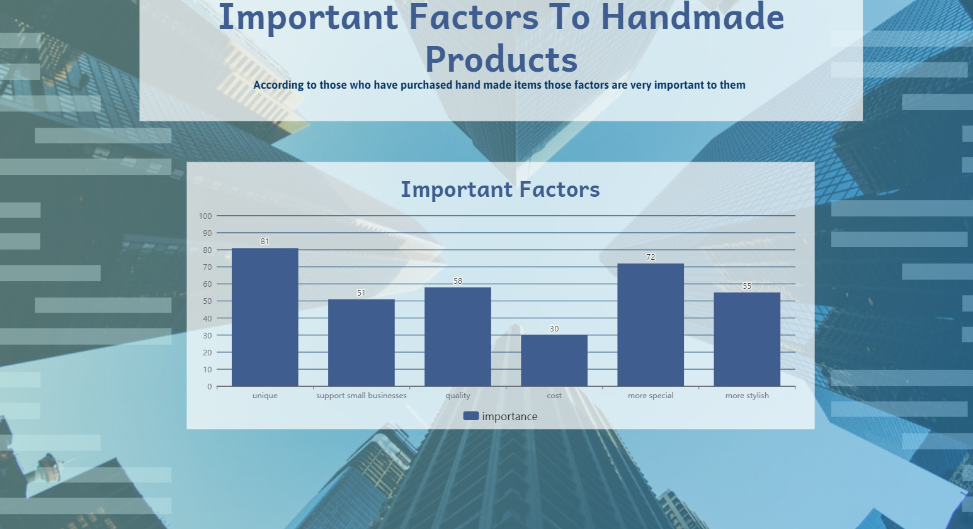

*Figure 4: Important factors to handmade products*

* + 1. **Our Survey**
  + We made a survey and this is the results:

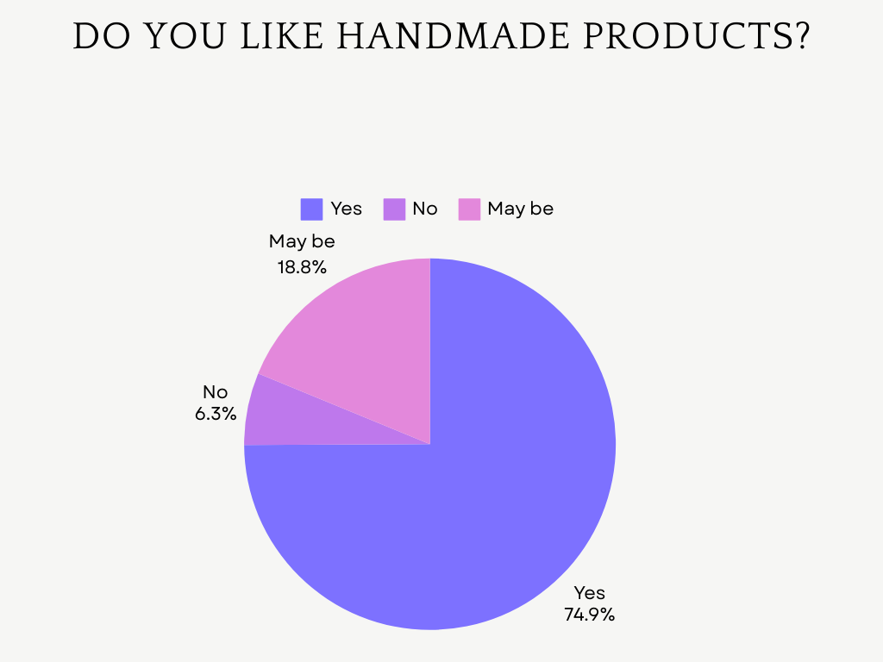

*Figure 5: Survey Q1*

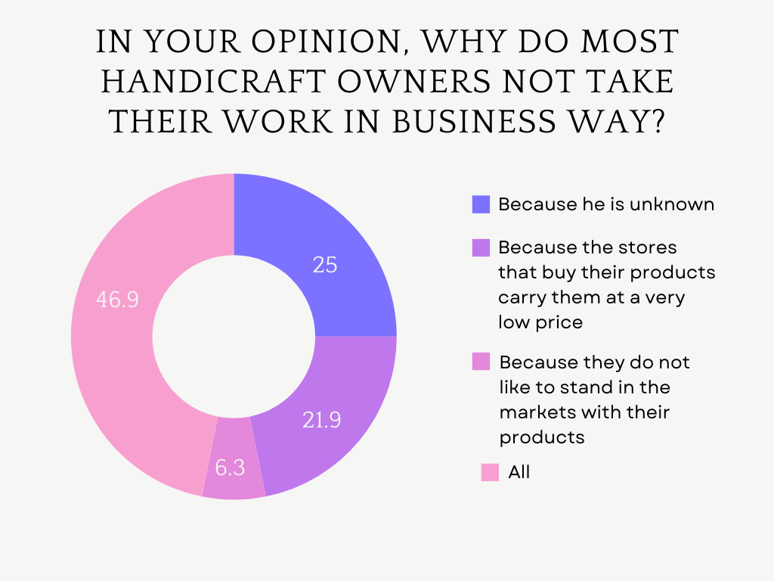

*Figure 6: Survey Q2*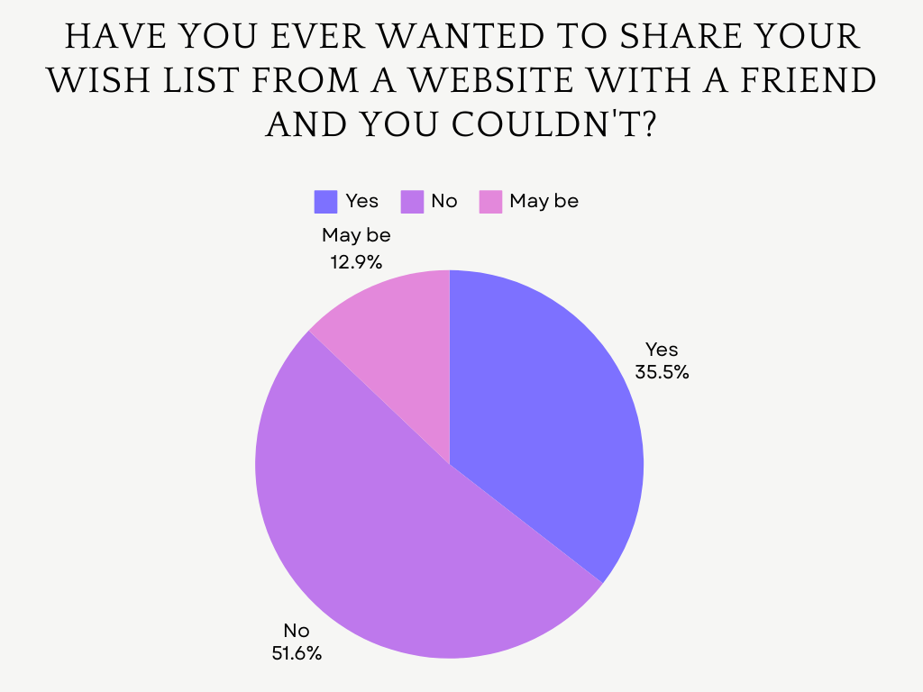

*Figure 7: Survey Q3*

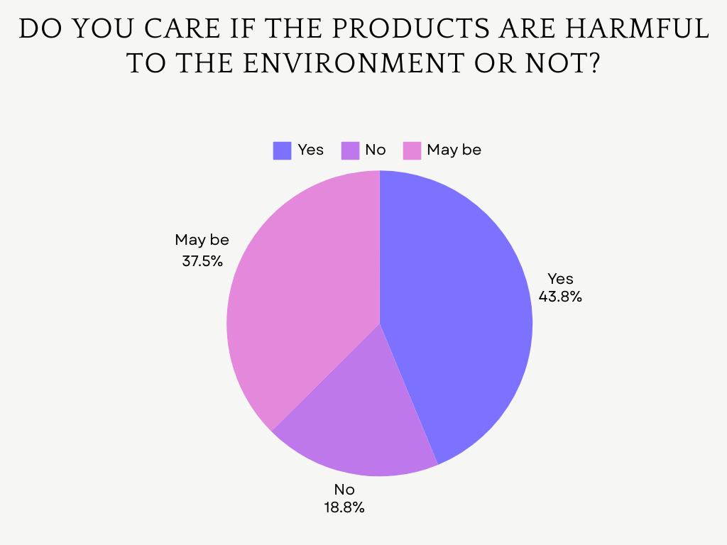

*Figure 8: Survey Q4*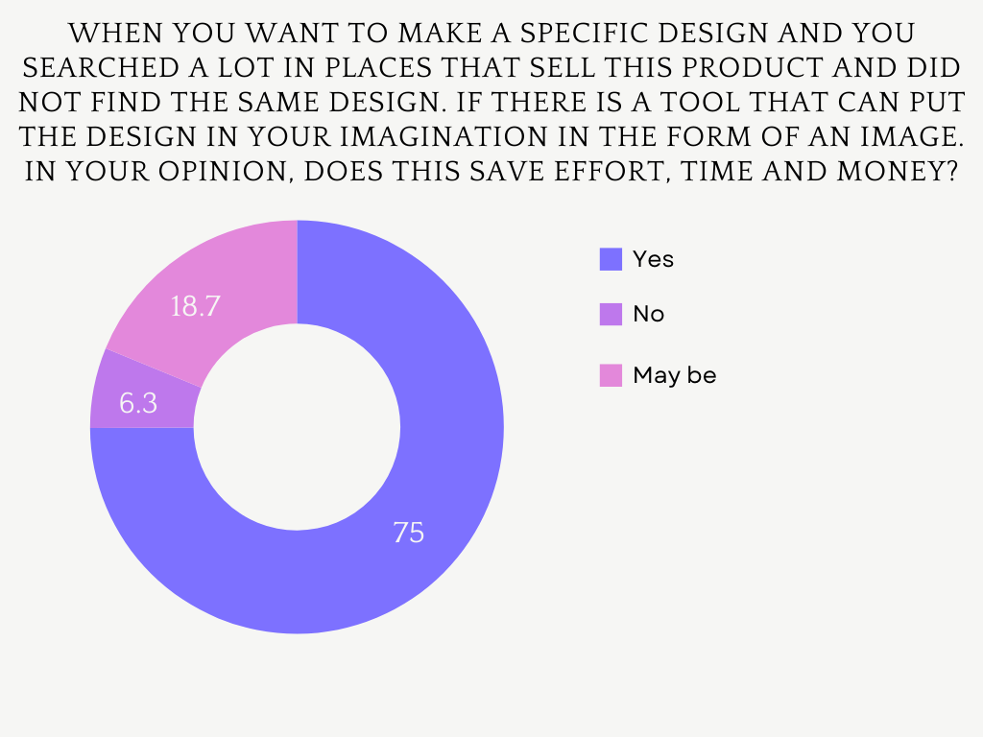

*Figure 9: Survey Q5*

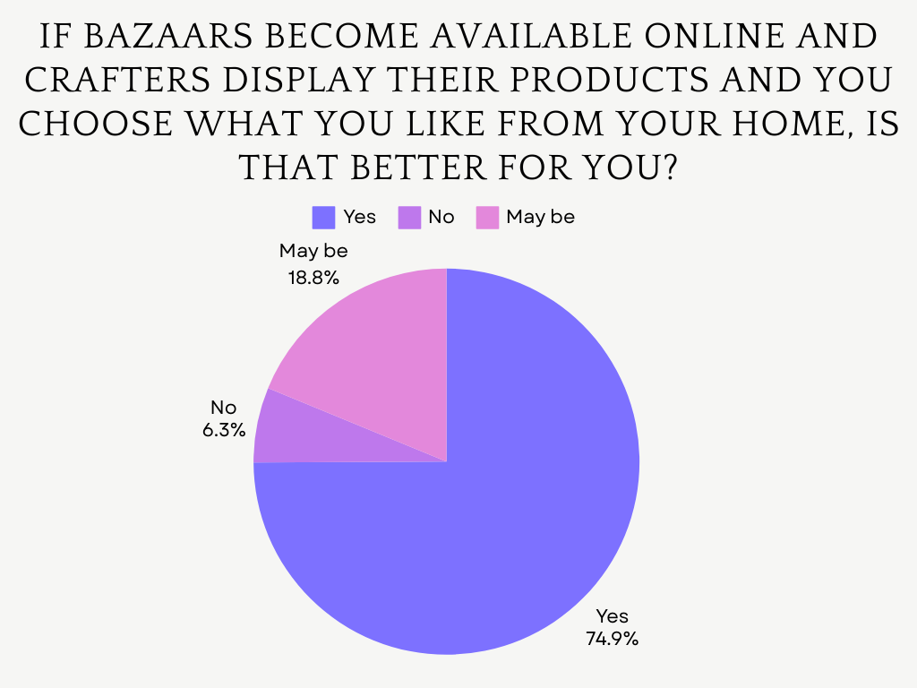

*Figure 10: Survey Q6*

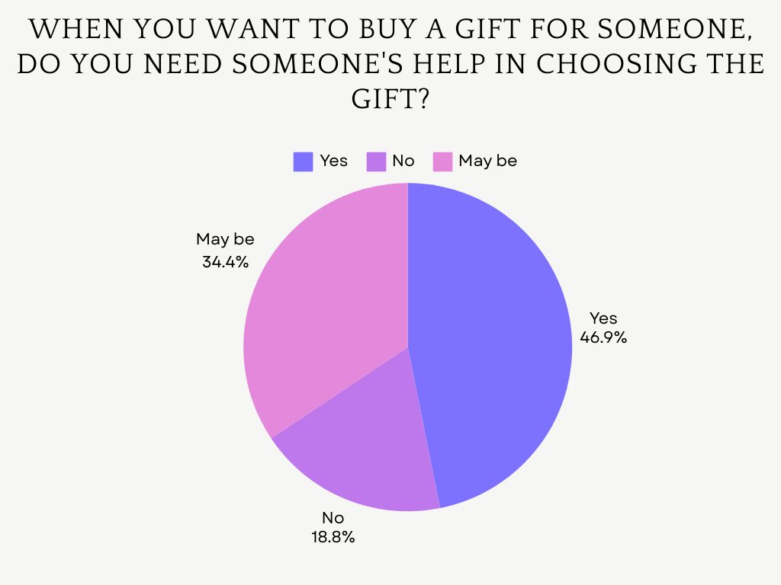

*Figure 11: Survey Q7*

* 1. **SWOT Analysis**
* **Strengths:**
* Variety of unique Services: Search by Photo, AI-driven gifting, and features specifically for handmade products like style advice AI.
* Ethical Shopping: Eco-friendly and boycott flags support users’ ethical purchasing choices.
* Engagement Tools: Event reminders and points keep customers engaged.
* Advanced Search and Comparison Tools: Search by photo and product comparison tools to help customers make informed decisions enhance the user experience.
* Personalization: AI and recommendation tools enhance user experience by making shopping more personalized.
* Unique Seller Customization: Sellers can customize their profile, providing them with a unique way to show their brand.
* Interactive Social Features: chat, gift cards, reels, and wish lists sharing enhances social commerce capabilities.
* Encourage customer to buy: give customers points every time there buy anything which they can exchange this buy other products.
* Enhancing customer confidence: give customers general feedback for the seller they contact with which make them comfort.
* **Weakness:**
* Complexity: Managing a wide range of features such as AI tools, personalized gifting, customizable profiles could make development more complex.
* User Awareness: Educating users about innovative features (e.g., AI-driven gifting) could be difficult without proper guidance and support.
* **Opportunities:**
* Demand for Ethical Shopping: Eco-conscious consumers are seeking platforms that align with their values, creating a strong opportunity for our eco-friendly feature.
* Customization and Personalization: Consumers are seeking unique, personalized products, and services, also sellers can customize their own profiles which our platform can provide.
* Increased Social Commerce: Features like chat, reels, sharing wish lists and send a gift cards tap into the growing trend of social shopping.
* AI Integration: Development of new AI-driven features, including recommendations and visual search and style advice AI creating a strong opportunity for our platform.
* Cost Advantage: Potential to attract sellers with lower fees.
* Cheaper product recommendations: Leveraging recommendations for cheaper products to attract budget conscious shoppers.
* Event and Bazar Advertising: Promoting offline and online bazars will create new marketing opportunities for sellers.
* **Threats:**
* Competition: Intense competition from established e-commerce giants.
* Technology Risks: Relying on AI and advanced features can introduce potential technical challenges that affect the user experience.
  1. **Gap Analysis**
* **Current State:**
* Limited features for handmade and bazar sections both online and offline are uncommon in e-commerce platforms.
* AI integration is minimal or limited to basic product recommendations.
* Ethical shopping features eco-friendly does not commonly exist.
* Platforms rarely provide interactive social features such as wish list sharing, reels, and chat. ✓ Lack of personalization and customization tools, especially in areas like handmade products, AI-driven gifting, and AI to design.
* Sellers have little control over customizing their online store page.
* Few platforms offer photo search functionality, making product discovery less intuitive for users who prefer visual search methods.
* Limited options for personalized notifications for sellers or users based on their interests.
* **Desired future State:**
* **Enhance Handmade Product Offerings & bazars:**
* Create a specialized handmade section.
* Introduce an online bazar and offline bazar ads to provide unique selling opportunities.
* **Ethical Shopping Features:**
* Introduce eco-friendly to help users make ethical purchasing decisions.
* **AI-Driven Personalization and customization**:
* AI for personalized recommendations, gifting suggestions, and style advice to create a unique and tailored shopping experience and AI for customizing profiles.
* **Advanced Search and Comparison Tools:**
* Implement advanced search functionality like photo search and comparison tools to make product discovery more efficient.
* **Interactive and Social Shopping:**
* Add social features such as sharing Wishlist and gift card, Encourage engagement through event reminders, trend section, and a bazar section on the app.
* **AI-Powered Features:**
* Introduce AI-driven gifting and recommendation system.
* **Increased Engagement:**
* Use tools such as notifications for sellers, interest-based recommendations, event reminder, and points systems to improve user retention and activity
* **Faster and Special Delivery Options:**
* Offer express delivery and a special order (faster delivery) option to cater to users looking for faster shipping.
* **GAP**

1. **Bazar and Offline Ads:**

* Gap: Lack of platforms offering an online bazar or offline bazar ads.
* Solution: Develop online bazar sections and offline advertising options for sellers.

1. **Ethical Shopping:**

* Gap: There is a lack of features promoting ethical shopping, such as eco-friendly flag.
* Solution: Introduce user-driven ethical tags to enable buyers to filter and choose products based on their values.

1. **AI-Driven Personalization and customization**:

* Gap: Current platforms have a Lack of customization tools in areas like customize profiles and personalization tools, especially in areas like handmade products, AI-driven gifting, and Ai to design.
* Solution: Implement AI-driven tools that suggest gifts, design ideas, and style advice AI based on user preferences and customization tools.

1. **Search and Comparison Tools:**

* Gap: Search functionality on most platforms is basic and lacks intuitive tools like photo search and detailed product comparisons.
* Solution: Develop advanced search tools that allow users to find products through images and provide detailed comparison features to help users make informed decisions.

1. **Social Features:**

* Gap: Current e-commerce platforms are missing strong social shopping elements like Wishlist sharing and gift cards.
* Solution: Integrate social commerce features, allowing users to share Wish lists, chat, upload reels for ‘sellers’, and send gift cards.

1. **User Engagement and Retention:**

* Gap: Platforms do not provide enough features that encourage repeated user engagement, such as points systems, trend section, or event reminders.
* Solution: Introduce a point system to reward purchases and activity, provide event reminders for special events, and make a trend section to keep users engaged.

1. **Handmade and Unique Offerings:**

* Gap: Platforms are not focusing on handmade or unique product sections.
* Solution: Create a specialized handmade section and enable sellers to post and offer unique items.
  1. **User Needs**
* **Visual Search Capability:** Customers want to find products quickly and easily through photo searches, especially for fashion, home decor, and unique items.
* **Personalized Shopping Experience:** Customers expect recommendations that align with their preferences, past purchases, and style. They also want personalized gifting suggestions, and style advice AI.
* **Ethical and Eco-Friendly Shopping:** Many customers prioritize ethical shopping, seeking eco-friendly products.
* **Comparison tool and affordable Alternatives:**
* Customers want the ability to compare products side by side to make informed purchasing decisions based on price, features, and reviews.

Price-conscious customers want to find cheaper alternatives to the products they are interested in.

* **Faster Delivery Options:** Some customers need fast shipping, especially for urgent purchases or special occasions.
* **Interactive and Social Features**: Customers enjoy social shopping experiences, such as sharing a Wishlist, sending gift cards, and receiving event reminders.
* **Rewards:** Customers prefer programs that reward them with points for purchases and activities, which can be changed for discounts or special offers.
  1. **Handcrafter Needs**
* **Lower Fees:** Sellers want to maximize their profits, especially compared to other e-commerce platforms with higher fees.
* **Customizable Seller Profiles**: Sellers want to create a unique brand identity on the platform, with the ability to customize their profiles and showcase their products effectively.
* **Promotional Tools:** Sellers want features like discount posting, special offers and one-piece discounts to increase visibility and sales.
* **reels:** Sellers want to showcase their products with video content and engage customers.
* **Notifications:** Sellers want notifications about user activity, such as when a customer interacts with their products or posts.
* **Bazar and Offline Ads:** Sellers need offline bazar ads to promote their products to a local audience in addition to online sales.
  1. **Feasibility**
* **Technical Feasibility:**
* **Development Platform:** The Application can be developed using Flutter for cross-platform mobile apps or Kotlin for Native Android apps.
* **AI Features:** AI-powered features like photo search, gifting recommendation, and style advice AI will require integration with machine learning libraries or platforms. Some of them may need a custom model trained using our data.
* **Eco-friendly tags:** Each item will have its respective flag stored in its meta-data.
* **Custom Handmade Products Section:** These can be natively developed into the application or be integrated into the main app as a service or a module.
* **Database:** NoSQL databases like Firestore or MongoDB handle large volumes of product data efficiently.
* **Loyalty Points and Gift Cards:** Existing loyalty and gift card APIs can be integrated or custom-built, depending on the needs of the software.
* **Online Bazars:** This feature can be supported using tools like virtual event management APIs or integrating third-party services.
* **Comparison Tool:** It can be implemented with search algorithms and price scraping tools, fetching the best results across our product inventory.
* **Server Hosting:** Hosting on cloud platforms like AWS, Azure, or Google Cloud will offer reliable and scalable servers.
* **Economic Feasibility:**
* **Initial Development Costs:**
* **Marketing:** Digital marketing budget for initial user acquisition.
* **AI integration (Photo search, gift recommendation, style advice):** Data collection and model training costs.
* **Backend infrastructure:** server and hardware costs.
* **Operational Costs:**
* **Cloud hosting services**: Pay-as-you-go models (AWS, Azure) based on traffic.
* **AI API usage:** Ongoing costs for services like Google Cloud Vision API, or hosting custom-trained models.
* **Maintenance:** Regular updates, bug fixes, and enhancements will incur ongoing expenses.
* **Logistics and express delivery:** The cost of the drivers or the third-party logistics company we are contracted with.
* Marketing: The costs of social media ads and deals with popular brands.
* **Revenue Streams:**
* **Sales commissions:** Earnings from transactions.
* **Subscription models:** For premium users or businesses.
* **Advertising:** Brands can pay for visibility in trend sections or recommendations.
* **Loyalty Points:** Encouraging user retention, thus increasing long-term revenue.
* **Operational Feasibility:**
* **Target Audience:**
* **Sellers:** Artisans, small business owners, and hobbyists who produce handmade products.
* **Buyers:** Individuals seeking custom or handmade goods, often focused on eco-friendliness or supporting local crafts.
* **User experience:**
* The app must have a smooth and intuitive UI/UX to handle complex features like AI-driven recommendations, wholesale purchases, and event reminders.
* **Logistics and Delivery**:
* Integrating with multiple delivery partners for express options will ensure smooth operations and 24/7 express deliveries.
  1. **Risk Analysis**
* **Technical Risks**

|  |  |  |  |
| --- | --- | --- | --- |
| **Risk** | **Occur** | **Affect** | **Solution** |
| Issues with image reorganization | M | H | -Use reliable AI image recognition APIs.  - test extensively on a variety of images. |
| Inappropriate Recommendation | L | H | -Continuously refine AI algorithms.  - collect user feedback. |
| Synchronization issues | L | H | -strong backend scheduling systems.  - notification testing. |
| Inability predicts trends | H | M | -real-time analytics integration. |

* **Resource Risks**

|  |  |  |  |
| --- | --- | --- | --- |
| **Risk** | **Occur** | **Affect** | **Solution** |
| **Difficulty of management different types of users** | **M** | **H** | **- Clear responsibility and duties for each type of users.** |
| **Delay in Delivery (Low experience –**  **Low Budget)** | **L** | **H** | **- Choose a trusted company to work with.**  **- Manage our delivery (Hard) FP.** |
| **Quality Control problem** | **H** | **H** | **- Implement a verification process.**  **- Fair return policy.** |

* **Time Risks**

|  |  |  |  |
| --- | --- | --- | --- |
| **Risk** | **Occur** | **Affect** | **Solution** |
| **A lot of trials for AI systems** | **H** | **M** | **-Use a reliable third-party AI system**  **- Built AI systems from the beginning.** |

* **Stakeholders Risks**

|  |  |  |  |
| --- | --- | --- | --- |
| **Risk** | **Occur** | **Affect** | **Solution** |
| **Fake or biased rating** | **H** | **H** | **- Add conditions to allow rating.** |
| **Unknown quality on second hand and handmade** | **H** | **H** | **- Make customer choose material, sizes…** |
| **Inconsistent user experience on**  **Bazar** | **M** | **H** | **- Make every seller clarify all things about products.** |
| **Misleading eco-friendly flags** | **M** | **M** | **- Ensure transparent verification processes.**  **- Clarify criteria for applying such flags to products.** |

# <Project title> Analysis

This chapter describes the main problem, the functional, and non-functional requirements, stakeholders and their responsibilities, and system scenarios. Students are free to elicit the suitable set of UML diagrams to fully describe the system in details. Examples of essential UML diagrams are use case, class, and sequence diagrams.

* 1. **Section 3.1**

XX

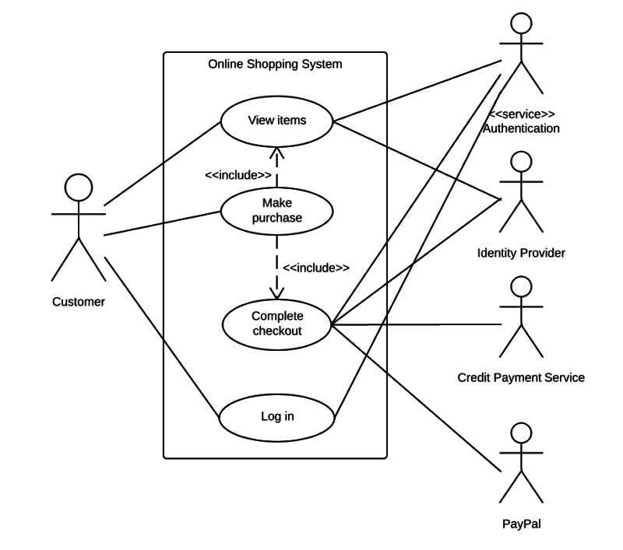

**Figure 3. Use Case Example**

* 1. **Section 3.2**

XX

# <Project title> Design and Implementation

This chapter describes in depth how every aspect of the project was designed, implemented, or created. It should contain the system prototype screens and the used tools and programming languages along with selection reasons.

* 1. **Section 4.1**
  2. **Section 4.2**

# <Project title> Testing and Evaluation

This chapter contains some of the detailed system test cases, used testing tools, and the test results of each system requirement. It also includes a project evaluation in terms of

* ***Cost (if possible)***
* ***Time compared to contemporary systems (if possible)***
* ***Environmental impact (if any)***
* ***Social and Political Impact (if any)***
  1. **Section 5.1**
  2. **Section 5.2**

# Conclusions and Future Work

This chapter includes conclusions to validate the system needs and how the presented system solved the problem stated. Finally, describe future suggestions to improve the system.

* 1. **Section 6.1**
  2. **Section 6.2**